Orthopaedic Associates of Dallas
3900 Junius Street Suite 500
Dallas, Texas 75246

Anil K. Koganti, MD

Office: (469)800-7200

RETURN APPOINTMENT:

If not already set-up, call to schedule your first post-operative appointment. This is typically 10-14 days after surgery. This is usually scheduled for you in advance and can be found in your surgery packet/ email.

DRESSING:

Keep the dressing placed in the operating room clean and dry. Remove the dressing two days after surgery and cover the wound with Band-Aids® as needed. If there is any drainage, cover the wound with a clean gauze dressing. Do not remove the stitches or small tapes (Steri-Strips®) covering the incision.

BATHING:

You may shower two days after surgery. Try to avoid direct spray on the surgical incisions, but it is fine for soap and water to run over the incision sites. Do not soak the wounds. Dry off the incision when done and leave open to the air. If desired, you may cover with Band-Aids® while showering, but this is not required.

SLEEPING:

- Sleep as upright as possible, such as in a recliner, for the first few weeks as this is usually the most comfortable position. This will also help to reduce swelling. If you do not have a recliner, use a wedge pillow in the bed or sleep on the end of a sofa, using pillows to elevate your head and torso.
- Getting comfortable at night is one of the main challenges after shoulder surgery. It is not common to be able to sleep through the night during the first couple of weeks, but this will gradually become easier.

ACTIVITY:

- Ice your shoulder several times a day for about 20 minutes at a time with an hour break in between icing sessions. This will help with inflammation and pain. Make sure to place a barrier between your skin and the ice (ex: wash cloth, t-shirt).
- Sling: Wear AT ALL TIMES (even sleeping) except for showering or gentle exercises as described below. The sling will prevent you from doing most movements that may jeopardize the repair. It is okay to tighten or loosen the straps to adjust how much your elbow is bent. The purpose of the sling immobilizer is to keep you from raising your arm. If the material on the sling is irritating your skin, it is helpful to place a cotton cloth or towel inside the sling as a barrier.
- Gentle exercises: You can remove the sling to move your elbow, wrist and hand 3 times a day. Work on making a fist with your hand and flexing/extending your wrist. This will help to pump some of the fluid/swelling out of your hand and forearm. When your sling is off, it is okay to let your elbow straighten and let your arm dangle at your side. This is perfectly safe as long as you don’t try to reach out or raise your arm up.
- Pendulum exercises may be performed once your initial pain level starts to ease up. While keeping the operative arm fully relaxed, bend forward at the waist and gently swing the arm in a gentle circle (see diagram below).
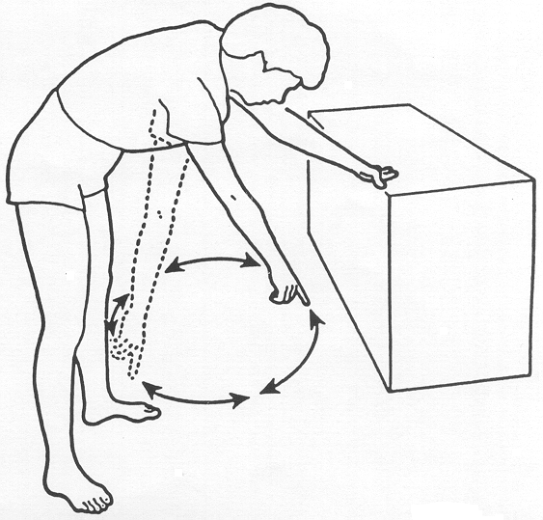

- Do not try to raise your arm up or reach forward. Do not push off on the arm to reposition in your chair or bed. Do not carry any weight on the operative side that is heavier than a coffee cup or cell phone.
- Try to walk around the house periodically. Make sure that you are not feeling dizzy or unsteady when you first get up.
- Physical Therapy: Will begin about six weeks after your surgery unless otherwise noted.
- DO NOT DRIVE until cleared by Dr. Anil Koganti.

MEDICATIONS:

- You may take over-the-counter ibuprofen, naprosyn/naproxen, Advil®, Aleve®, Motrin® or any prescription “anti-inflammatories” if needed after surgery. You can take these if the prescribed narcotic pain medication is not sufficient to manage your pain. Before taking ibuprofen or other NSAIDs, please ensure that you are not allergic to these types of medication. You may also not be able to take NSAIDs if you are on blood thinners, have a history of bleeding stomach/intestinal ulcers, or have kidney disease. If you are not sure, please check with your primary care physician.

- Pain Medication: Normally, Norco (hydrocodone + acetaminophen) or Percocet (oxycodone + acetaminophen) will be prescribed as your pain medication. One tablet can be taken every 4-6 hours as needed for pain. Do NOT take more than a total of 10 tablets per day. This could harm your liver due to acetaminophen toxicity.

- Do not take Tylenol® in addition to the narcotic pain medication or drink alcohol while taking the pain medications. You may substitute a dose of Tylenol® for a dose of Norco/Percocet but do not take both at the same time.
- If pain is severe, you may take two tablets every 6 hours as needed for pain until it can be managed with one tablet.
- If pain is not manageable with the prescribed narcotic pain pill, it may be helpful to take ibuprofen in between the pain medication doses. For instance, if you are taking the pain pill at 12:00 pm, 4:00 pm, 8:00 pm (i.e., every 4 hrs), you may consider taking 400 mg of ibuprofen at 2:00 pm, 6:00 pm, and 10:00 pm, etc. Thus, you will be able to take some form of pain medication every 2 hrs.
- The pain medication may cause constipation. You may need to take a stool softener and/or laxative while taking the pain medication. Colace, Miralax, or Dulcolax can be helpful. Increasing your water intake may help as well.

- Nausea is common with these types of medications and can occur with all varieties of pain medications. It is not an “allergy.” Taking the medication with some food or liquid in your stomach is best. A nausea medication (promethazine or Zofran) may have been prescribed for you. Take this only if needed to help with nausea.

- Muscle relaxers (methocarbamol) may have been prescribed. These help to relax the muscles around your shoulder and to ease any spasms or tightness in your neck and shoulder blade area. They may also help to relieve some of the pain. Methocarbamol may be taken every 8 hours as needed, but is not required. Patients often find that the muscle relaxer is most helpful at night, as it may cause drowsiness. It is okay to take along with the pain medication.

- If the anesthesiologist performed a “block” before your surgery, your arm may feel “asleep” for 10-12 hours after surgery. While your arm is asleep, it is a good idea to periodically check your arm position in the sling. Make sure that the hand bolster is not too tight on your palm/fingers. Once the block begins to wear off, your pain will intensify. It is a good idea to begin taking your pain medication (hydrocodone, oxycodone, codeine, or tramadol) starting about 8 hours after your surgery, even if you are not experiencing any pain. This will help you to “get ahead” of the pain. Pain is typically “at its worst”on the first 2 days after surgery. This will begin to ease up day by day at that point. Reduce your pain pill intake as pain level improves.

PROBLEMS TO REPORT:
- Fever greater than 101°F.
- Incision becomes very red, progressively swollen, or is persistently draining.

